27. The Czech Republic
Is the president of the Czech Republic a pen stealer?
As just about anyone who's ever worked in an office can attest, one of life's most festering annoyances are people who don't return pens that they borrow. Now it appears as though Czech Republic President Vaclav Klaus may be one of those people, and the citizens of the nation he rules over are none too pleased about it.

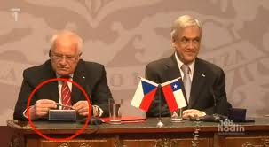
You see, Klaus, whose most notable prior controversy was probably his flat rejection of climate change science—a position that he even appeared on Glenn Beck's show to tour— was caught on video coyly pocketing a ceremonial pen during a recent visit to Chile. What's more, the brazen stylus heist took place in full view of the media during a ceremony to announce a trade agreement. The video shows Klaus clearly admiring the pen, then slowly moving it into one of his jacket pockets as Chilean President Sebastian Pinera speaks to the assembled members of the media.
Now, Reuters is reporting that some Czech citizens are accusing Klaus of being a kleptomaniac. But the president's staffers claim that he had every right to take the pen—and that he was, in fact, acting entirely in line with established Czech state protocols. "We at the Prague Castle always give such a pen to delegations, along with a notepad: presidential spokesman Radim Ochvat told the news agency.
(news.yahoo.com)
- What two controversial issues connected with Vaclav Klaus does the article mention?
  - rejection of climate change, “stealing” a pen
- How, according to the article, does the president's office justify his “theft”?
  - he had a right to take it, it’s fine with Czech state protocols
+How do you see it? Why?

