9. My favourite
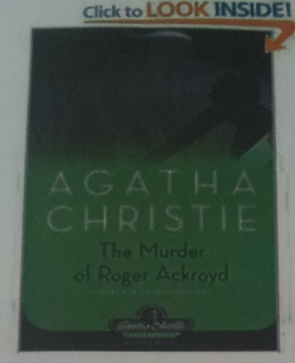
British or American writer
Hercule Poirot Mystery (Agatha Christie Collection)
[Hardcover)
Editorial Reviews From Library Journal
This novel, written in 1927, is considered the best and most successful of the early mysteries. It met with no small outrage when It appeared, as it uses a plot
device many readers thought "unfair." There is a full complement of characters
populating the cozy English village of King's Abbot: Major Blunt, Colonel Carter, Miss
Gannett, the butler, the housekeeper, the narrator, Dr. Sheppard, and his know-it-all
sister (the precursor of Miss Marple, according to Christie), and, of course, the
redoubtable Hercule Poirot and his little grey cells. There are clues with a capital C to
mislead us, and the listener gets so involved with these tricks (or not) that the very
simple truth remains unobserved. Venerable reader Robin Bailey keeps the light, almost
comic tone alive, although his voices are not particularly differentiated, and often he
rushes the reading of dialog. A classic of the genre and essential for any fiction collection.
Harriet Edwards, East Meadow P.L., NY
Questions:
- This is a review of an audio-book. True / False
- True
- According to the author, who originally played the role of Miss Marple?
- Dr. Sheppard’s sister
- What genre is this book? How do you like this genre. Justify your opinion.
- Novel (prose) / detective story

